**Pure substances, Mixtures and Bonding - Revision Questions**

1. Define:

mixtures, homogeneous and heterogeneous mixtures, pure substance, elements, compounds, solvent, solute, solution, nanomaterials

1. Give examples of above terms.
2. Distinguish between a pure substance and a mixture.
3. Describe the difference between simple and fractional distillation.
4. Diagram of simple distillation and label different parts.
5. Name and explain the three different types of chemical bond that hold atoms together. (Type of attraction between particles)
6. Learn the structure of Iodine
7. What would be the ratio of atoms formed by bonds between:
8. Carbon and chlorine
9. Sodium and nitrogen
10. Explain in terms of structure and bonding who do silicon dioxide and sulphur dioxide have different melting points.
11. Arrangement of particles in in an ionic substance. Explain with the help of a diagram.
12. Why do ionic compounds do not conduct electricity in solid form but does conduct when dissolved in water?
13. Diagram showing structure and bonding within a metal.
14. What are the properties of metals, ionic compounds, covalent compounds? Explain in terms of structure and bonding.
15. Learn the separation technique for a mixture of NaCl and CuCl2. Label the diagram for the filtration technique.
16. Explain why diamond acts as a poor conductor of electricity.
17. Properties of graphene.

Graphene is an allotrope of carbon consisting of a single layer of carbon atoms arranged in a hexagonal lattice. It is a semimetal. It is the basic structural element of many other allotropes of carbon, such as graphite, charcoal, carbon nanotubes and fullerenes.

[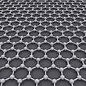](http://en.wikipedia.org/wiki/Graphene)

The key **difference between** graphite and **graphene** is that graphite is an allotrope of carbon having a high number of carbon sheets whereas **graphene** is a single carbon sheet of graphite.

Graphane is a two-dimensional polymer of carbon and hydrogen with the formula unit (CH)n where n is large. Graphane should not be confused with graphene, a two-dimensional form of carbon alone. Graphane is a form of hydrogenated graphene.

1. Properties of graphene.

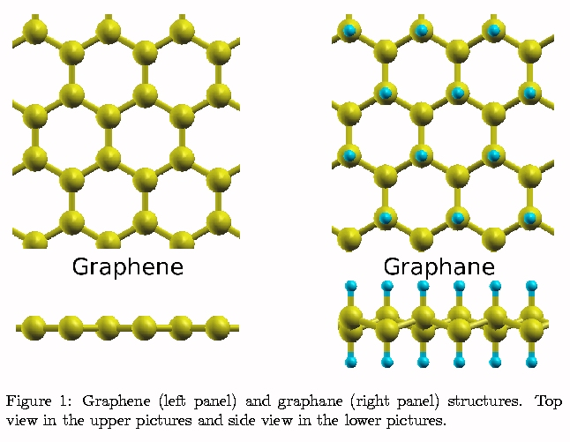

1. What is 1 nanometre in meters and in millimetres.
2. What are carbon nanotubes? Properties of carbon nanotubes explain in terms of structure and bonding.
3. Name the type of bond formed between carbon atoms in a nanotube.
4. Why do scientists feel that nanoparticles are subject to increased regulations?
5. Formulas / names of compounds

Lithium chloride--------------

Phosphorous tribromide---------------

Ammonia----------------------

Ammonium dichromate------------

Dinitrogen tetroxide ------------------------

N2O ----------------------

Ca3N2 -----------------------

SF6 ------------------------------

H2O2 -------------------------------------

1. Draw structural formula representing all valence shell electron pairs as: or as –